Your code snippets should have line number and a theme like below, different from your description(You could use code snapshot extension in VSCode.)

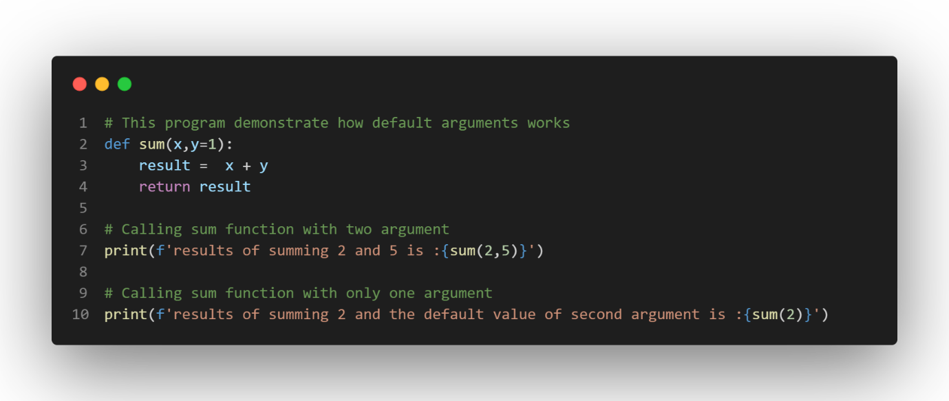

**Exercise Part Title (Times New Romar Bold, size 14)**

Description paragraph should write with Calibri(Body) 12, like this.

**References**

1. your references should write in this section as a numbered list, with Times New Romar(Regular font size 12)
2. reference 2
3. …